

DreamHome Project Report

Course : CS310(Database Management Systems)

Course Instructor : Dr. Pramod Yelmewad

# Table of Contents

1. Introduction
2. Project Scope
3. Methodology
4. Results
5. Future Scope
6. Conclusion

# Introduction

Real estate is one of the most lucrative industries in the world. With the rise of digital platforms and online marketplaces, buying and renting properties has become easier than ever. However, despite the technological advancements, managing and organizing property listings, clients, and transactions can still be a daunting task for real estate agents and property managers. To address this challenge, we developed a database management system for real estate agents that enables them to easily manage their property listings, clients, and transactions in a single platform. This system simplifies the process of property management and provides a comprehensive solution to streamline the real estate business. In this report, we will discuss the design and implementation of this system, highlighting its key features and functionalities. We will also provide a detailed analysis of the benefits of this system for real estate businesses, its potential impact on the industry, and its future scope.

# Project Scope

The Property Rental System is a web-based application that enables property owners to list their properties for rent and tenants to search and book rental properties. The system will consist of two main user roles: property owners and tenants. Property owners will be able to register and log in to the system, add properties for rent, manage property details, view and respond to tenant requests, and track rental income. Tenants will also be able to register and log in to the system, search for available rental properties, submit rental applications, and make rent payments.

The project will cover the following functionalities:

* Property Registration : Property owners can register their properties with it’s details like rent, location, type etc
* Client Registration : Tenants can fill out a form about their preferences and register themselves as clients.
* Property Listings : The clients will get weekly listings which are in accordance with their preferences. Also, the clients can comment on these properties. Based on the comments, more suitable listings will be provided.
* Admin dashboard: The system will have an admin dashboard to manage users, properties, rental applications, and rental payments.
* Lease : If a tenant chooses to rent a property and the payment is done, a lease will be automatically drawn.

The project scope is limited to the above functionalities and does not cover advanced features such as online payments, complex property management, and sophisticated user management.

# Methodology

The implementation involved various steps like

### 1.Database Design

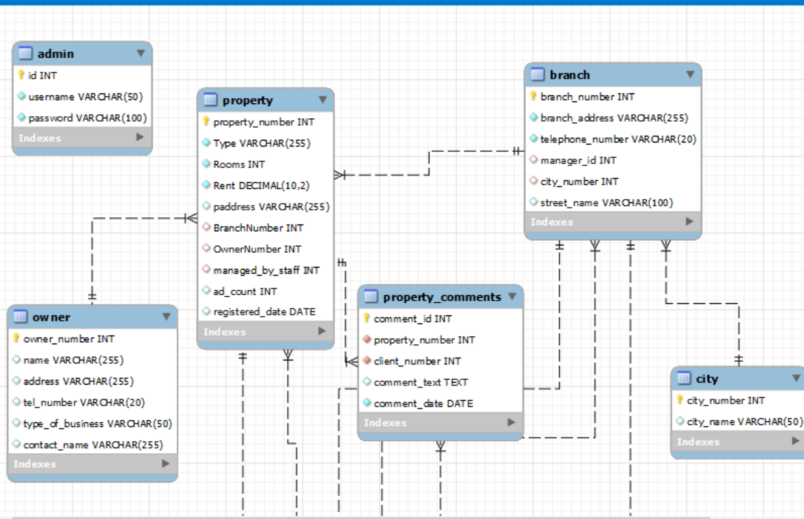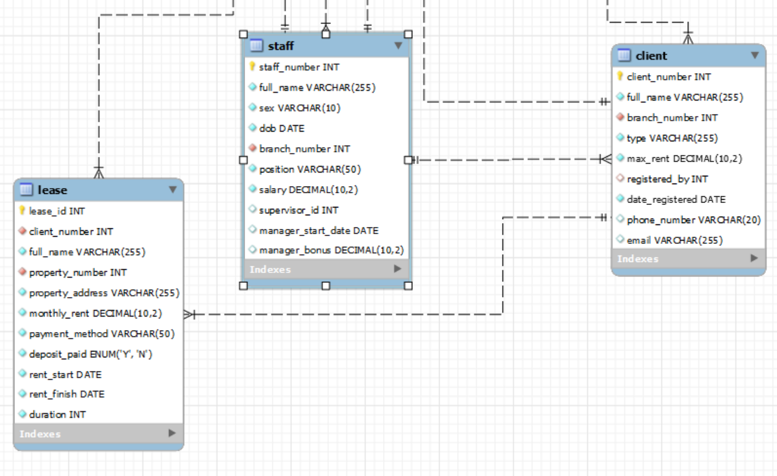

As you can see in the E-R diagram above, there are 9 tables in the DreamHome database.

1. Branch : This table contains details about a particular branch. It has attributes like branch_number(primary key), manager_id(references staff_number in the staff table – it indicates the manager of a particular branch, city_number(references city_number in the city table- it will indicate the city in which the branch is located), etc.
2. Staff : This table contains details about the staff working for DreamHome. It has attributes like staff_number(primary key), branch_number(references branch_number in the branch table- it will help in identifying the staff working for a particular branch) , etc.
3. City : This table consists of city_number(primary key) and city_name.
4. Property : This table contains details about a particular property. It has attributes like property_number(primary key), branchNumber( references branch_number in the branch table – It will indicate the branch that the property is registered in), OwnerNumber(references owner_number in the owner table – It indicates the owner of the particular property), managed_by_staff(references staff_number in the staff table – It will indicate the staff who is incharge of managing that particular property), etc
5. Owner : This table contains the details of property owners. It has attributes like owner_number(primary key), name, address etc.
6. Client : This table contains the details of clients. It has attributes like client_number(primary_key), branch_number(references branch_number in branch table – It indicates the branch in which the client is registered in), registered_by( references staff_number in the staff table- It indicates the person who registered the particular client), etc
7. Property_comments: It contains the comments made on a property by a client. It has attributes like comment_id(primary key), property_number(references property_number in the property table – It indicates the property on which the comment was made), client_number(references client_number in the client table -It indicates the client who made the comment), etc
8. Lease : It contains the details of the lease. It contains attributes like lease_id(primary key), client_number(references client_number in the client table- It indicates the client who leased the property), property_number(references property_number in the property table- It indicates the property that was leased), etc

### 2. Queries

Some dummy data was inserted into the tables . To ensure that the data is consistent and satisfies the requirements, all the queries provided were run.

**Query Set-1**

(a).List the details of branches in a given city.(example: London)

Query: SELECT b.*

FROM branch b ,city c

WHERE b.city_number=c.city_number and city_name='London' ;

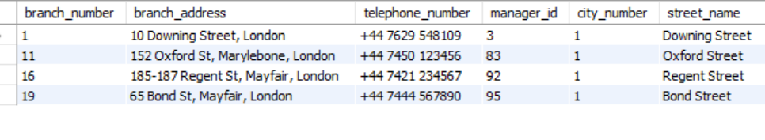

(b).Identify the total number of branches in each city.

Query:

SELECT count(branch_number) as Number_of_branches, city_name

FROM branch b ,city c

where b.city_number=c.city_number

Group by(b.city_number);

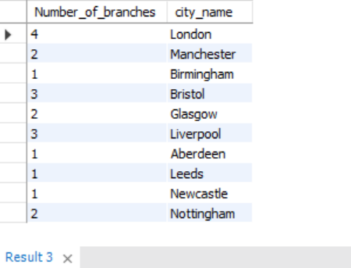

(c).List the name, position, and salary of staff at a given branch, ordered by staff name.

Query:

SELECT full_name,position, salary

FROM staff

WHERE branch_number=1 --example branch_number 1

order by full_name ;

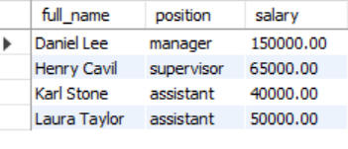

(d).Identify the total number of staff and the sum of their salaries.

Query:

SELECT count(staff_number) as Total_staff,

sum(salary) as Total_salary

FROM staff;

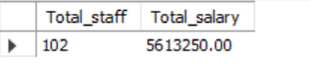

(e).Identify the total number of staff in each position at branches in Glasgow

Query:

SELECT position,count(staff_number) as number

FROM branch b, staff s,city c

WHERE b.branch_number=s.branch_number

AND b.city_number=c.city_number AND city_name='Glasgow'

GROUP BY position;

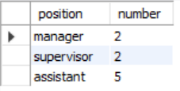

(f).List the name of each Manager at each branch, ordered by branch address.

Query:

SELECT full_name,s.branch_number

FROM branch b , staff s

WHERE b.manager_id=s.staff_number

order by branch_address;

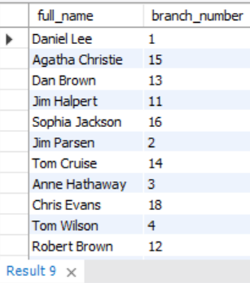

(g).List the names of staff supervised by a named Supervisor.

Query:

SELECT full_name

FROM staff

WHERE supervisor_id is not null;

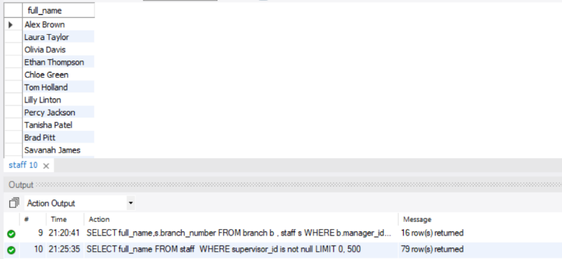🡪 Has more rows of information.

(h).List the property number, address, type, and rent of all properties in Glasgow, ordered by rental amount.

Query:

SELECT property_number, paddress,type,rent

FROM branch b, city c , property p

WHERE p.branchnumber=b.branch_number

And b.city_number= c. city_number and city_name='Glasgow'

order by rent;

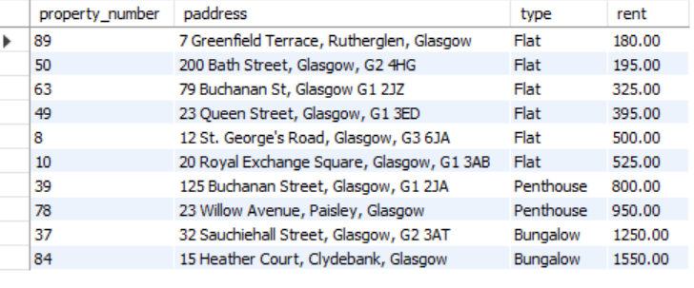

-- (i) List the details of properties for rent managed by a named member of staff

Query:

SELECT property_number,rent,type,full_name as managing_staff

FROM property p, staff s

WHERE p.managed_by_staff= s.staff_number;

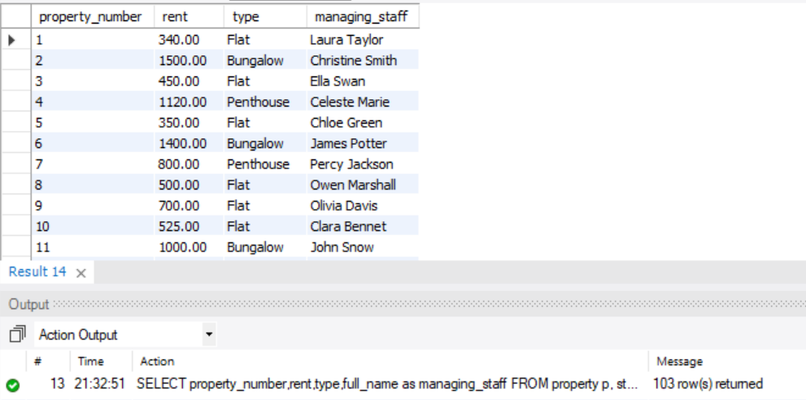

(j).Identify the total number of properties assigned to each member of staff at a given branch.

Query:

SELECT s.full_name, s.branch_number,

COUNT(p.property_number) as total_properties

FROM property p

JOIN staff s ON p.managed_by_staff = s.staff_number

GROUP BY s.full_name, s.branch_number order by branch_number;

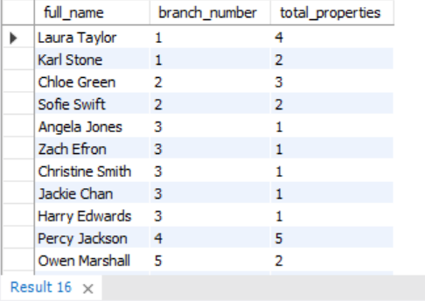

(k).List the details of properties provided by business owners at a given branch.

Query:

SELECT o.*

FROM owner o, property p, branch b

WHERE p.ownernumber=o.owner_number and p.branchnumber=b.branch_number and

o.type_of_business is not null;

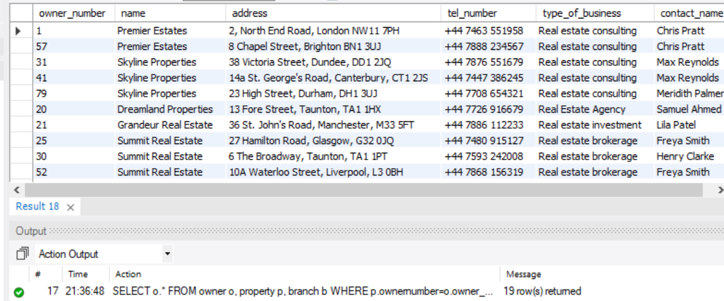

(l).Identify the total number of properties of each type at all branches.

Query:

SELECT b.branch_Number, p.type,

COUNT(DISTINCT p.property_Number) AS number_of_properties

FROM property p

JOIN branch b ON p.branchNumber = b.branch_number

GROUP BY b.branch_Number, p.type

ORDER BY b.branch_Number;

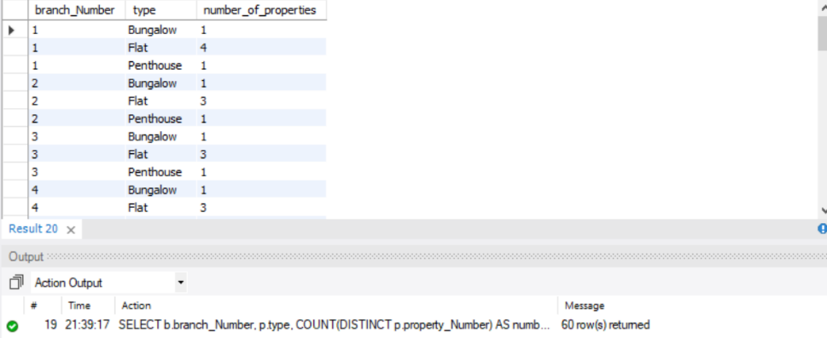

(m).Identify the details of private property owners that provide more than one property for rent.

Query:

SELECT o.*

FROM owner o ,property p

WHERE p.ownerNumber=o.owner_number and type_of_business is NULL

group by owner_number having count(*)>1;

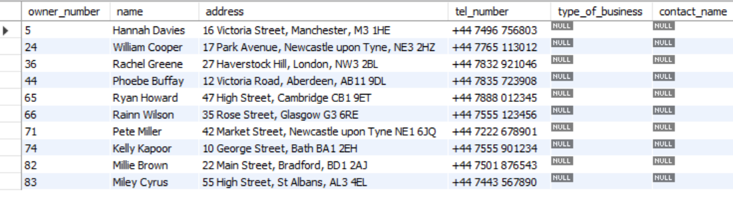

(n) Identify flats with at least three rooms and with a monthly rent no higher than £500 in Aberdeen.

Query:

SELECT property_number, type,rooms, rent, paddress

FROM property p, branch b, city c

where p.branchNumber=b.branch_number and b.city_number=c.city_number and city_name='Aberdeen' and rooms>=3 and type='Flat' and rent<=500 ;

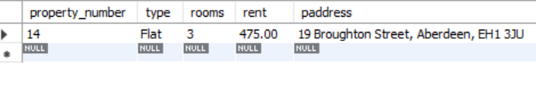

(o) List the number, name, and telephone number of clients and their property preferences at a given branch.

Query:

SELECT client_number,full_name,type, max_rent,phone_number,b.branch_number

FROM client c, branch b

WHERE c.branch_number=b.branch_number

order by c.branch_number;

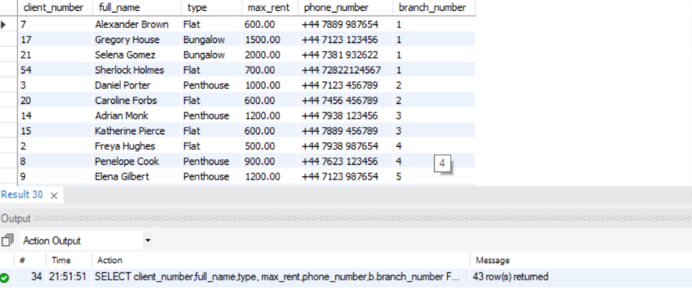

(P).Identify the properties that have been advertised more than the average number of times.

Query:

SELECT *

FROM property

WHERE ad_count > (SELECT AVG(ad_count) FROM property);

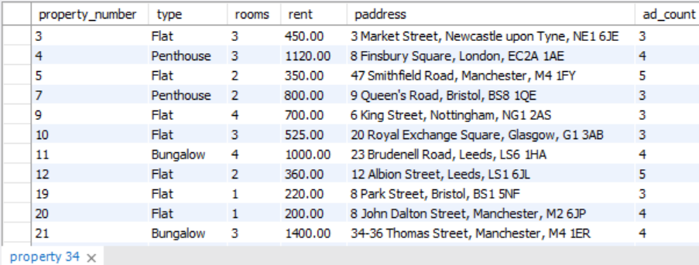

(q) List the details of leases due to expire next month at a given branch.

SELECT l.*

FROM lease l, client c, property p

where l.client_number = c.client_number

and l.property_number = p.property_number

AND MONTH(l.rent_finish) = MONTH(DATE_ADD(CURDATE(), INTERVAL 1 MONTH));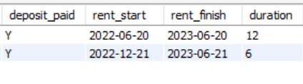

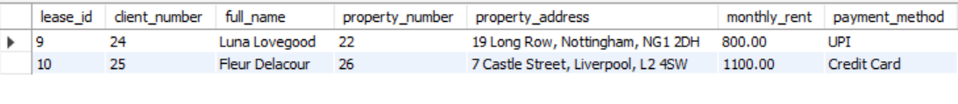

(r).List the total number of leases with rental periods that are less than one year at branches in London

Query:

SELECT l.*

FROM lease l, property p, branch b, city c

where l.property_number=p.property_number and p.branchNumber=b.branch_number and b.city_number=c.city_number

and c.city_name='London' AND duration<12;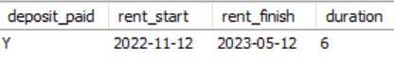

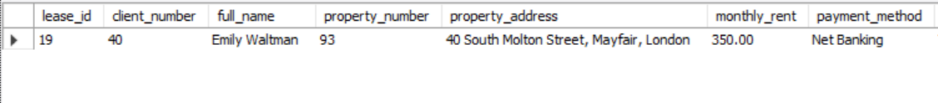

(s).List the total possible daily rental for property at each branch, ordered by branch number

Query:

SELECT BranchNumber, SUM(rent)/30/COUNT(*) as average_daily_rental

FROM property p

JOIN branch b ON p.branchNumber = b.branch_number

GROUP BY BranchNumber

ORDER BY BranchNumber;

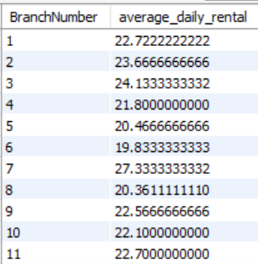

**Query-Set 2**

(a).List details of staff supervised by a named Supervisor at the branch.

Refer to Query-Set 1 (g).

(b).List details of all Assistants alphabetically by name at the branch.

Query: SELECT *

FROM staff

where position='Assistant' and branch_number=2

order by full_name;

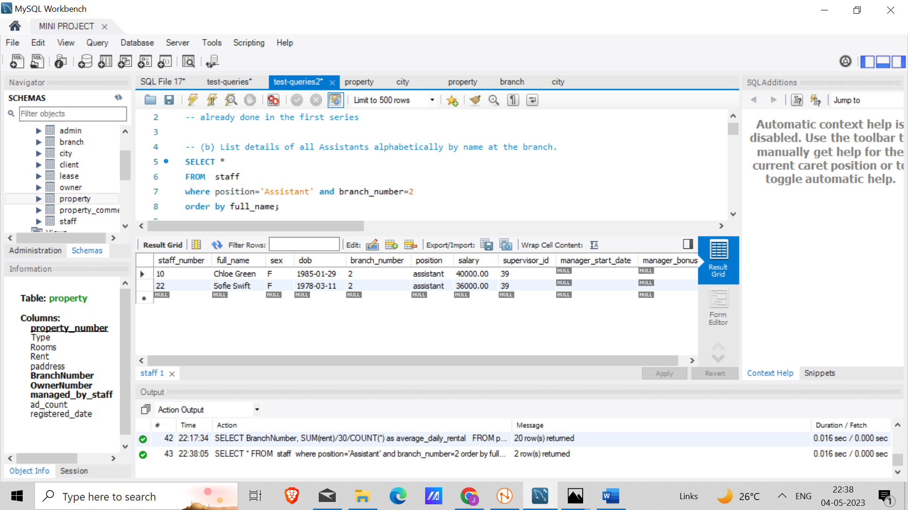

(c) List the details of property (including the rental deposit) available for rent at the branch, along with the owner’s details.

Query: SELECT property_number,type,rent,paddress,owner_number,name,tel_number

FROM property p , owner o

where p.ownernumber=o.owner_number;

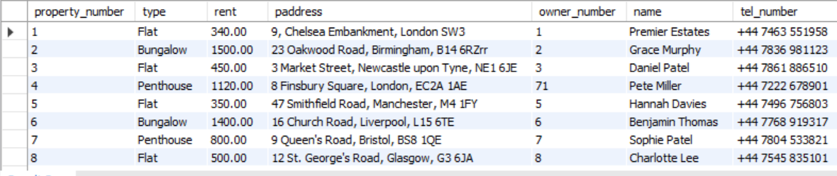

(d).List the details of properties managed by a named member of staff at the branch.

Query: SELECT p.*

FROM property p, staff s

WHERE p.managed_by_staff=s.staff_number and s.full_name='Clara Bennet';

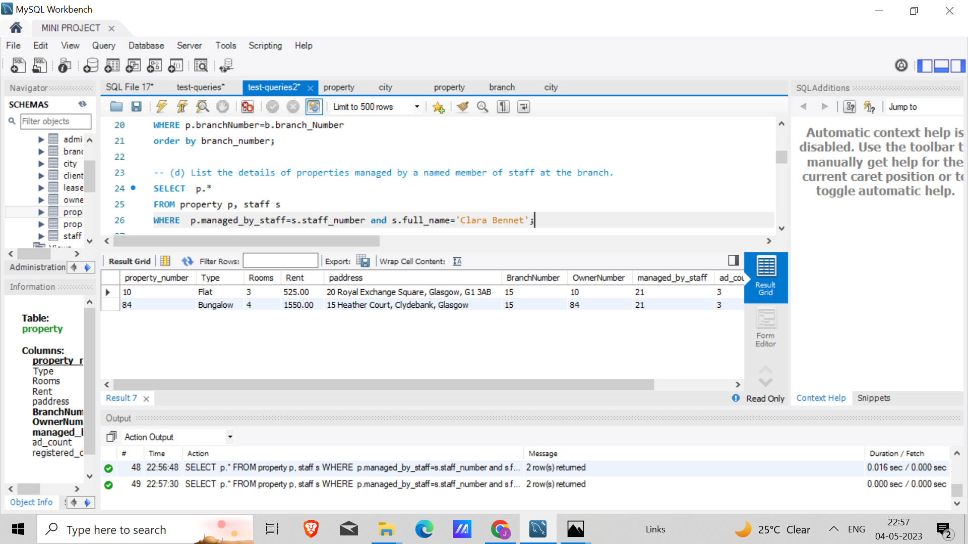

(e) List the clients registering at the branch and the names of the members of staff who registered the clients

Query: SELECT s.branch_number,c.full_name,client_number,s.full_name, staff_number

FROM client c, staff s

WHERE c.registered_by=s.staff_number

order by s.branch_Number;

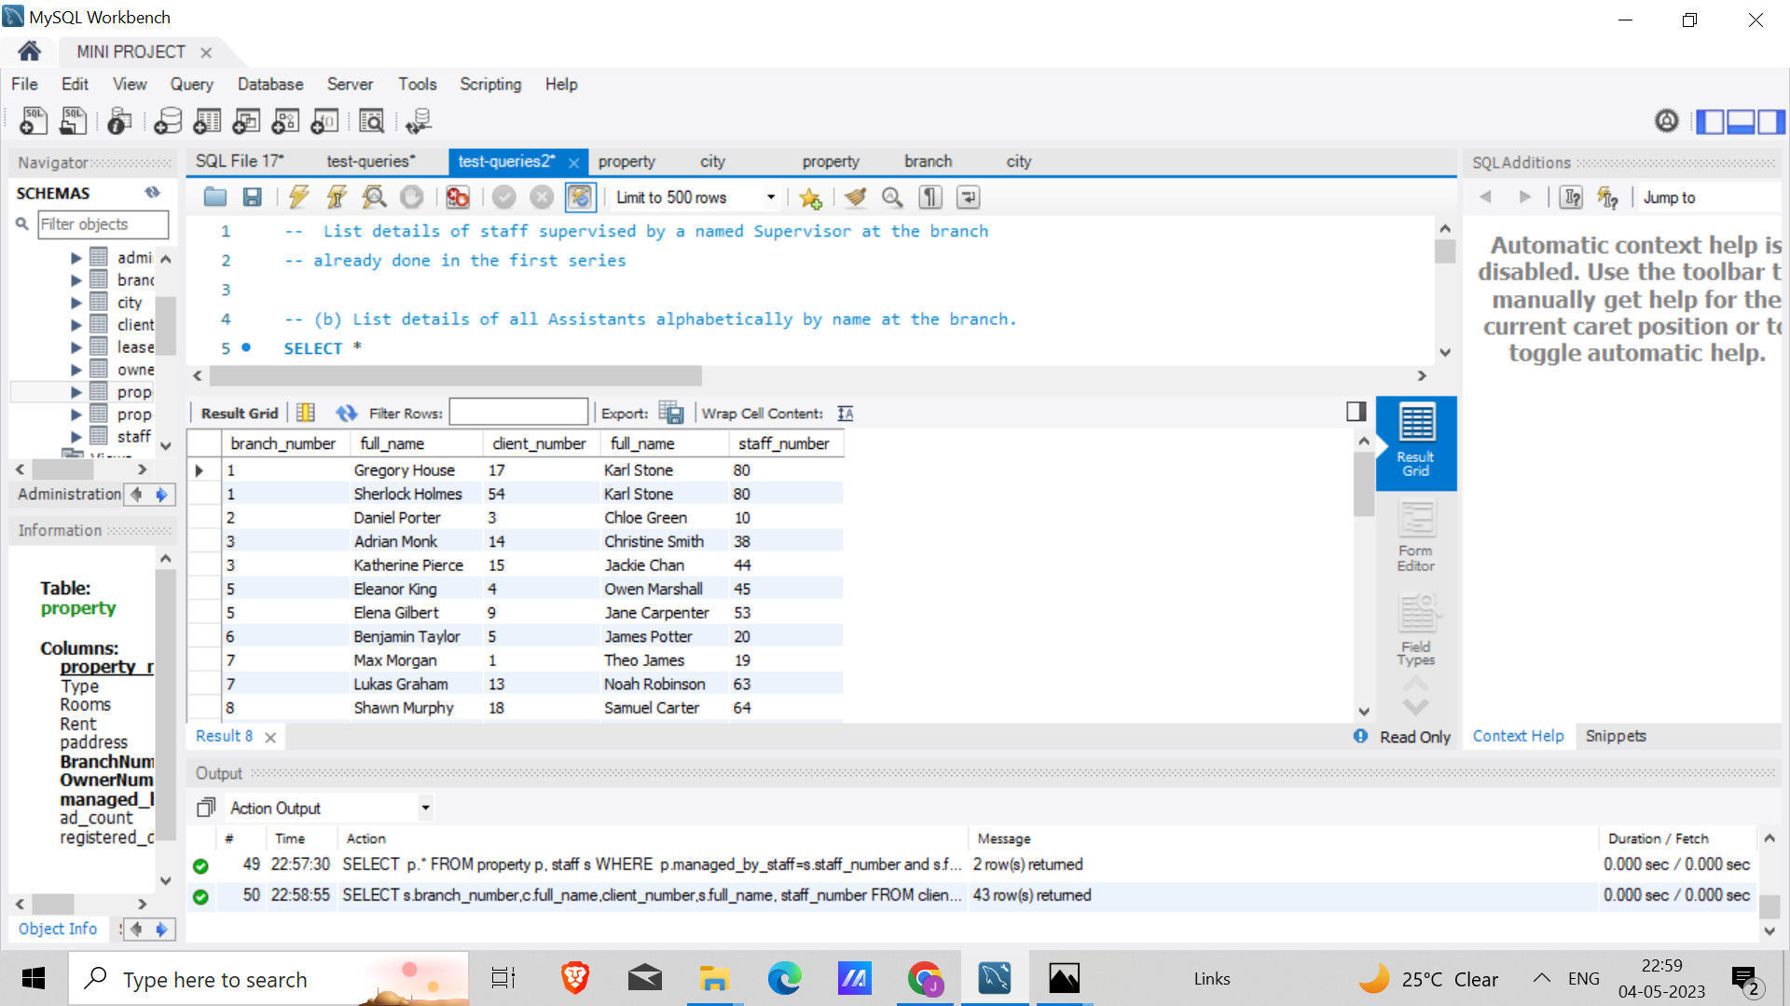

(f) Identify properties located in Glasgow with rents no higher than £450.

Query: SELECT p.*

FROM property p,branch b,city c

WHERE p.branchnumber=b.branch_number and b.city_number=c.city_number and city_name='Glasgow' and p.rent<450;

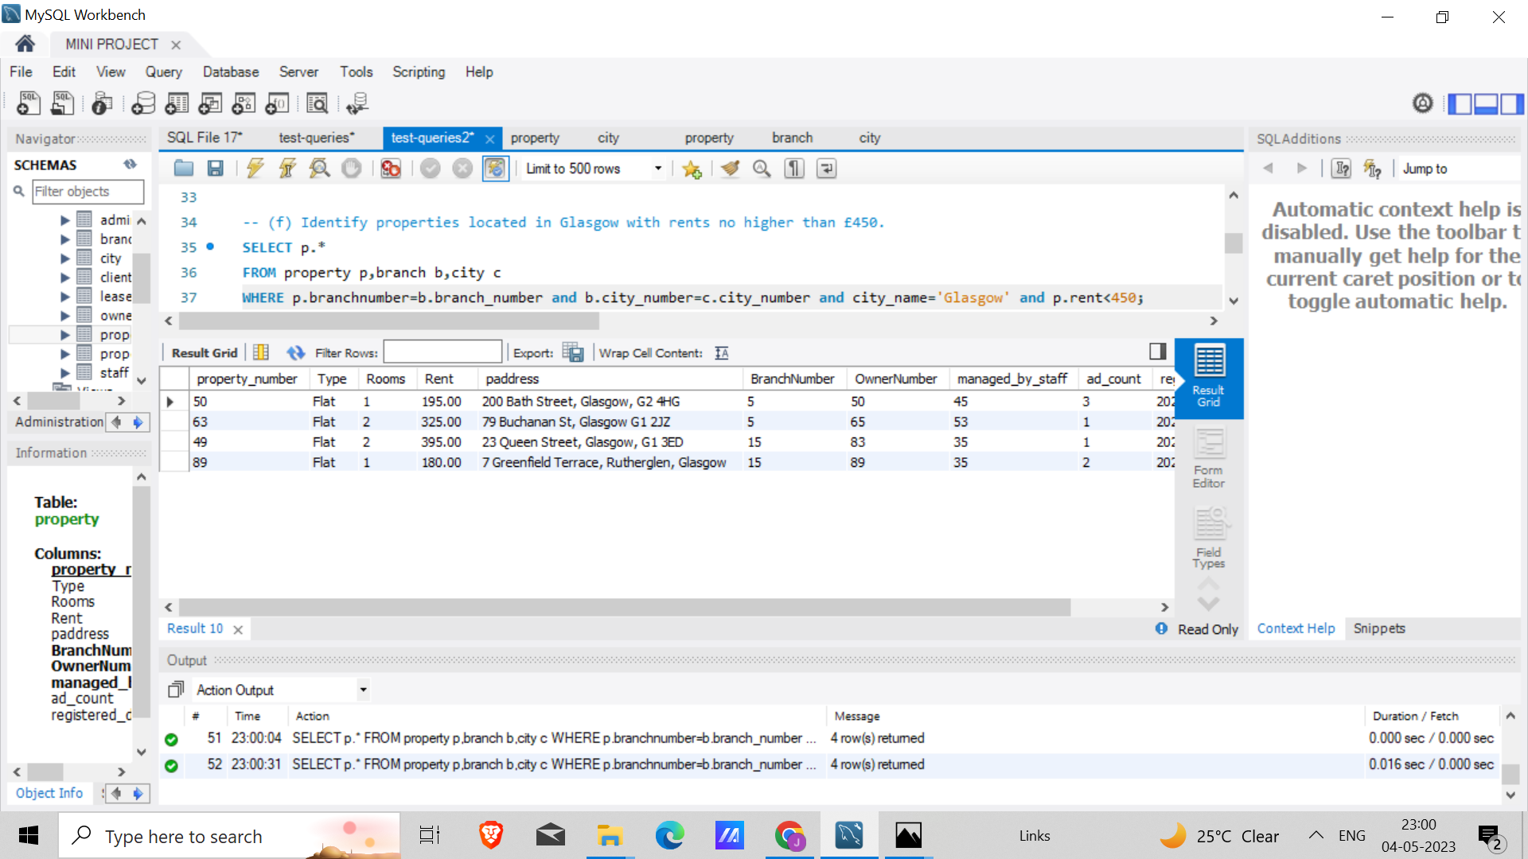

(g) Identify the name and telephone number of an owner of a given property.

Query: SELECT name,o.tel_number,property_number

FROM property p, owner o

where p.ownernumber=o.owner_number ;

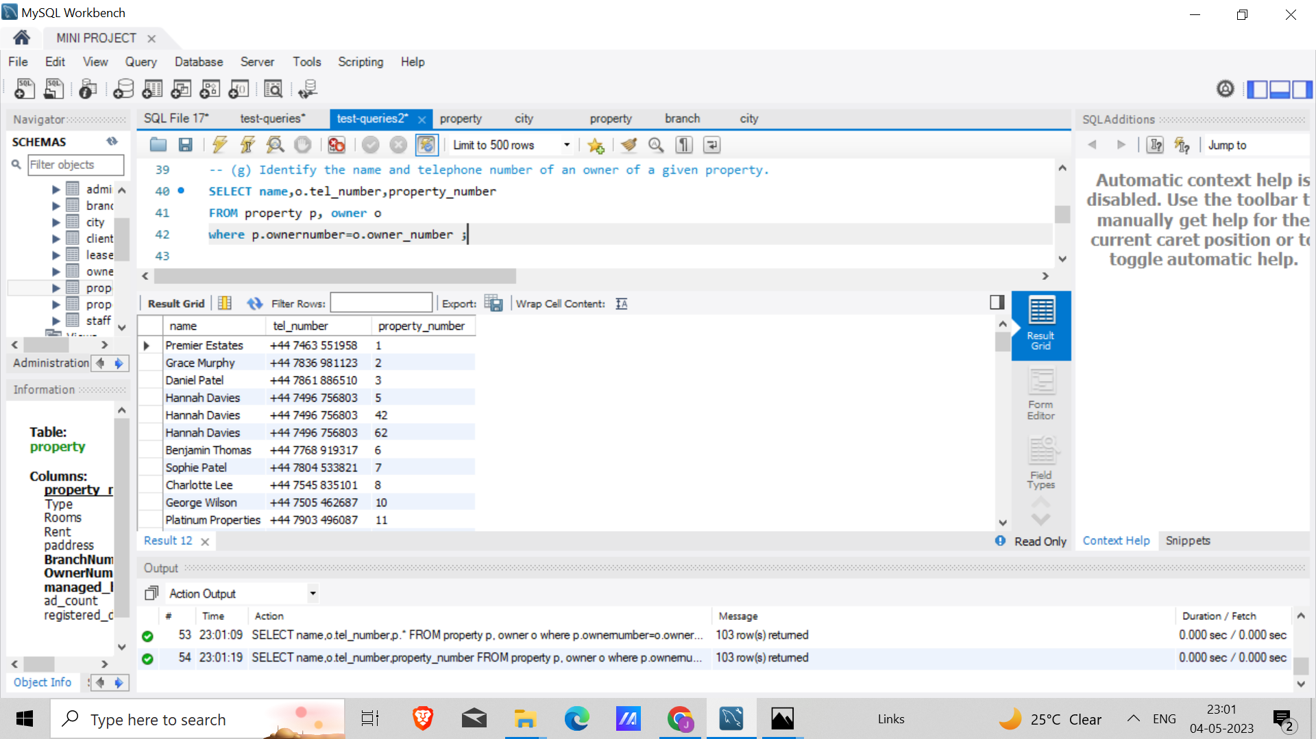

(h) List the details of comments made by clients viewing a given property

Query: SELECT *

FROM property_comments WHERE comment_text is not null;

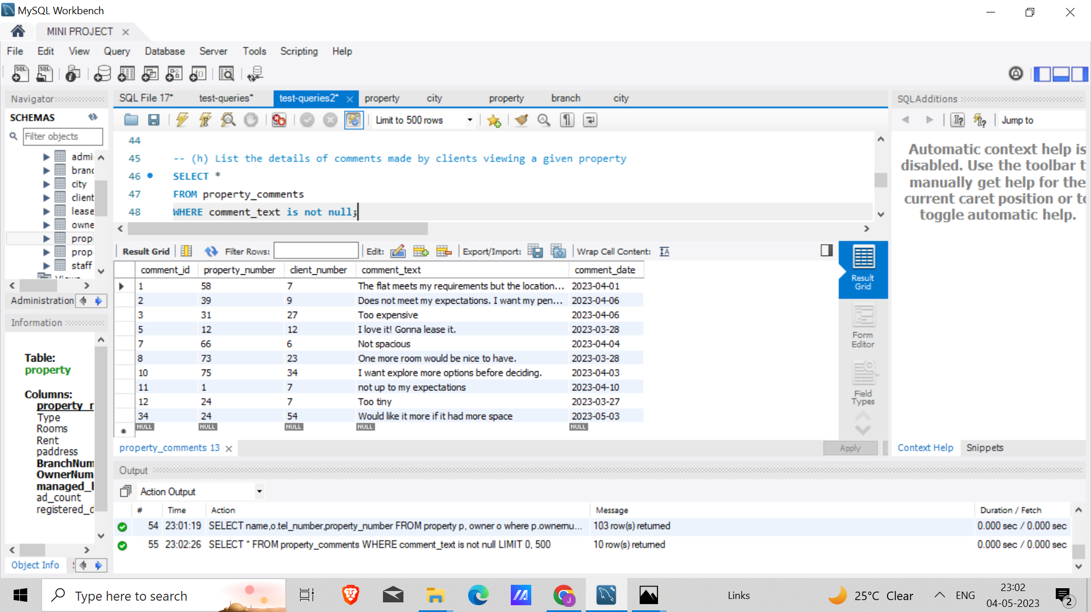

(i) Display the names and phone numbers of clients who have viewed a given property but not supplied comments.

Query: SELECT full_name,phone_number

FROM property_comments p, client c

where p.client_number=c.client_number and comment_text is null;

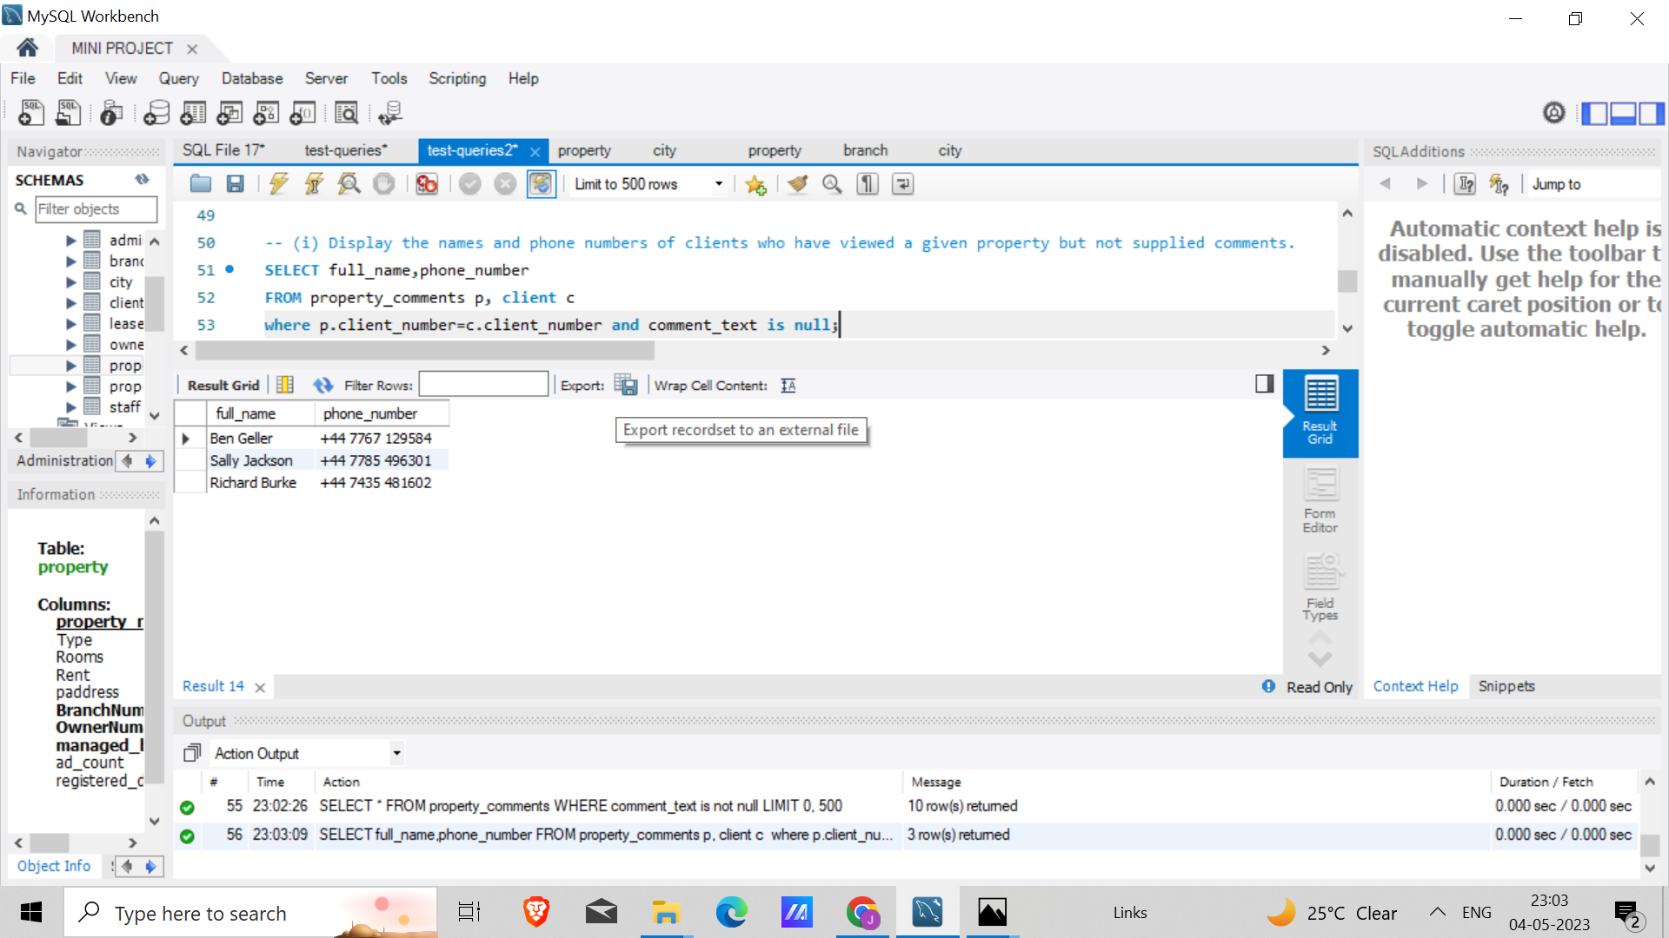

(j) Display the details of a lease between a named client and a given property.

Query: SELECT *

FROM lease

where full_name='Jerry Seinfeld';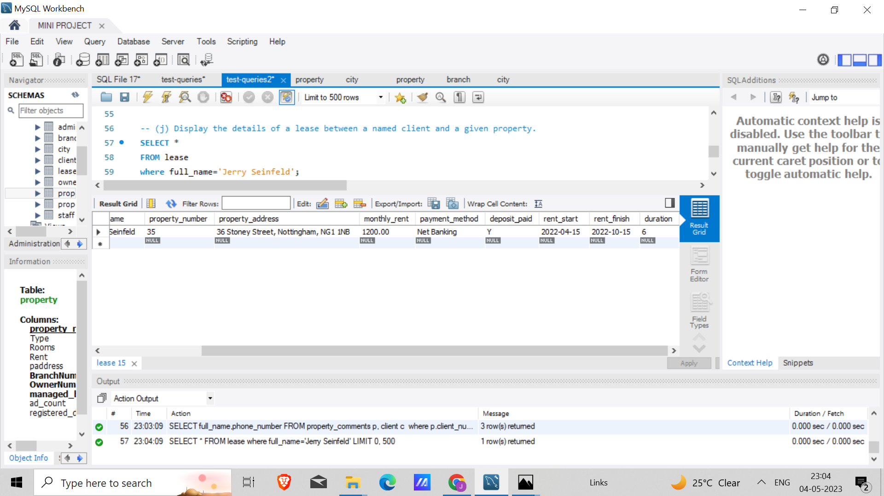

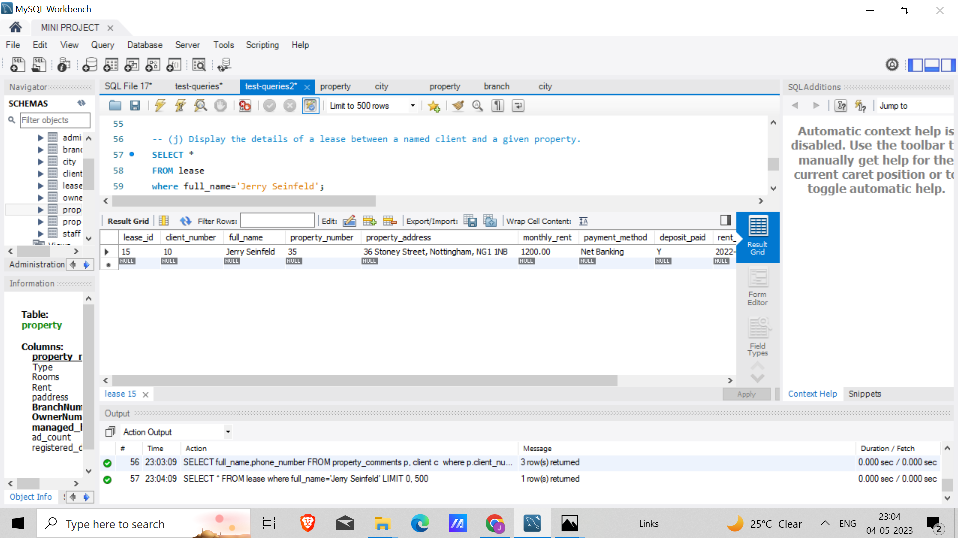

(k) Identify the leases due to expire next month at the branch.

Already done in Query-Set 1, (q).

(l) List the details of properties that have not been rented out for more than three months

Query: SELECT * -- Select all columns from the property table

FROM property p -- Alias the property table as p

WHERE p.registered_date <= DATE_SUB(CURDATE(), INTERVAL 3 MONTH) -- Filter properties registered within the last 3 months

AND NOT EXISTS ( -- Exclude properties that have active leases

SELECT *

FROM lease l

WHERE l.property_number = p.property_number

);

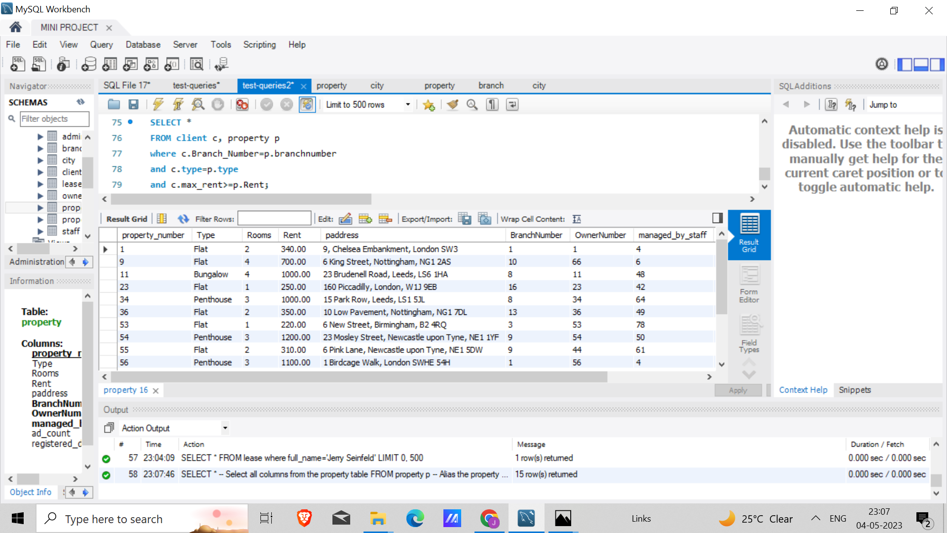

(m) Produce a list of clients whose preferences match a particular property

Query: SELECT client_number,full_name,property_number

FROM client c, property p

where c.Branch_Number=p.branchnumber

and c.type=p.type

and c.max_rent>=p.Rent;

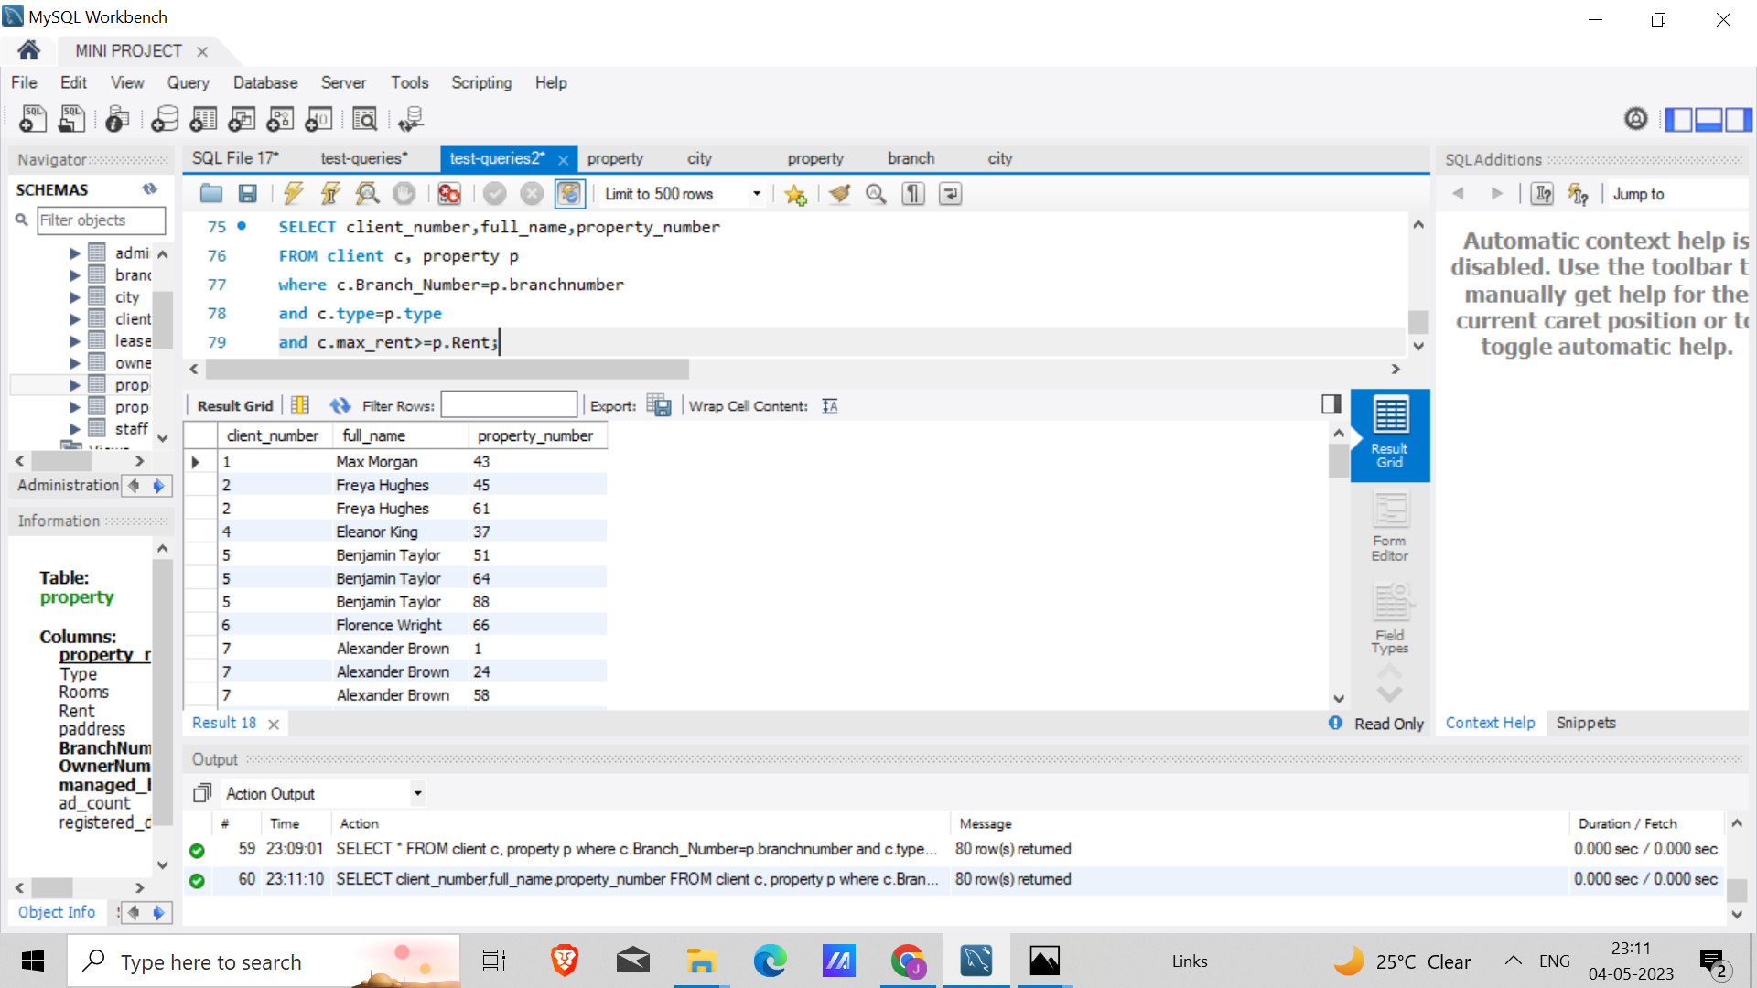

### 3. User Interface

Next the user Interface was built. This included 3 steps

1. Building the Front End : A very basic design was built using HTML , CSS and JavaScript. This included several forms like property registration, client registration etc
2. Backend : Node js was primarily used. MySQL database was connected to the forms so that the data from the forms go into the database.
3. Testing and Debugging

# Results

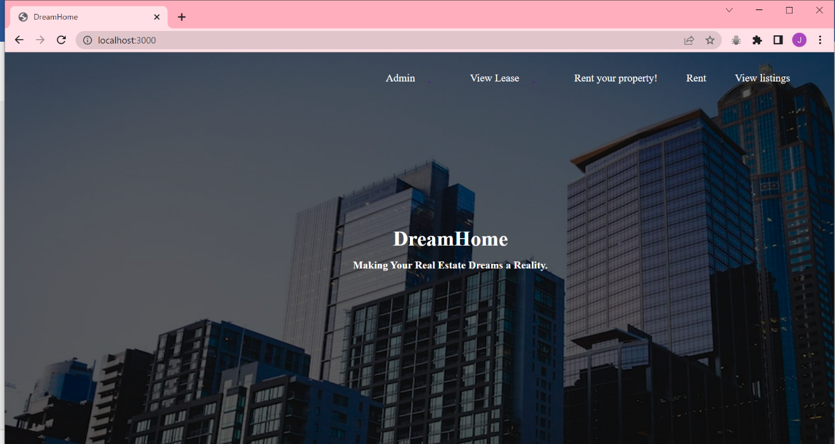

This is the homepage (currently deployed locally). Clicking on Rent will lead to the following form.

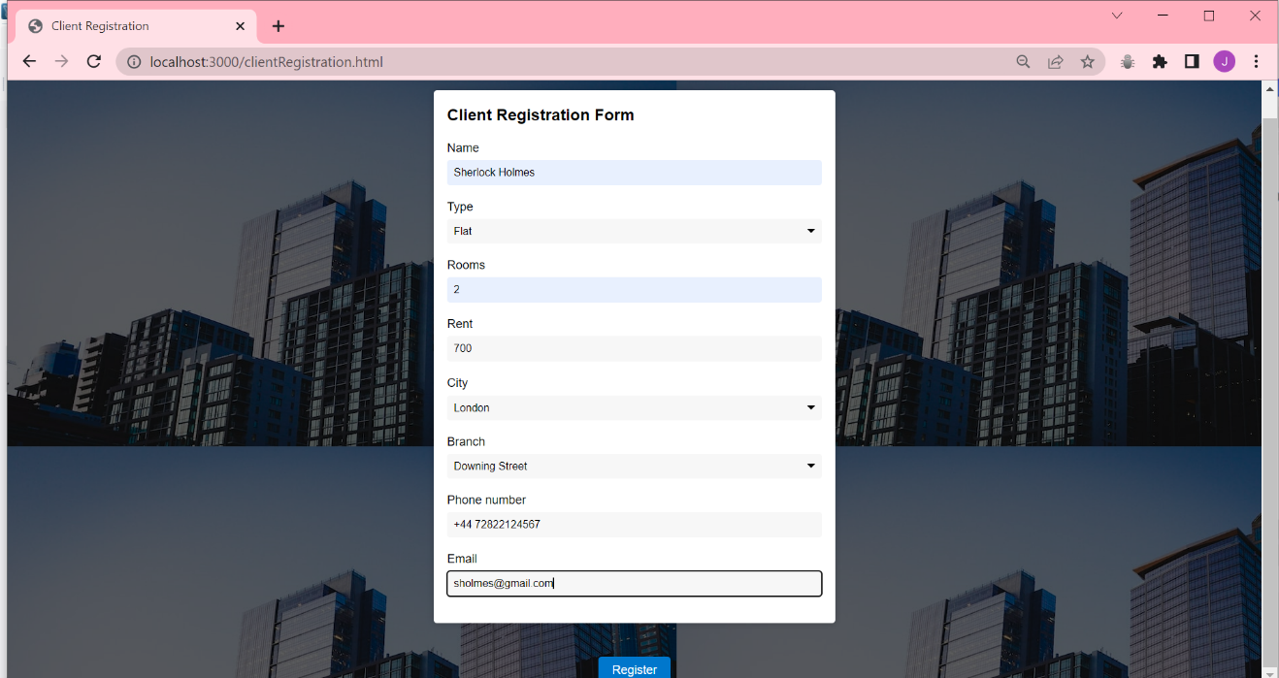

On clicking register,

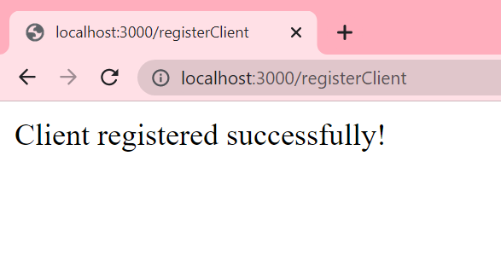

As this is connected to the database, this information will be fed to the client table.

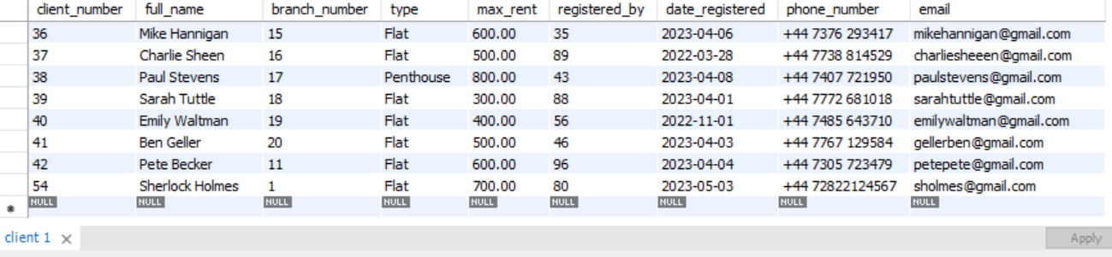

You can see that the information from the form is filled in the table.

The view listing feature is available, where the client will get property recommendations based on the preferences of the client. This option is only available for registered clients and can be accessed through their registered emails.

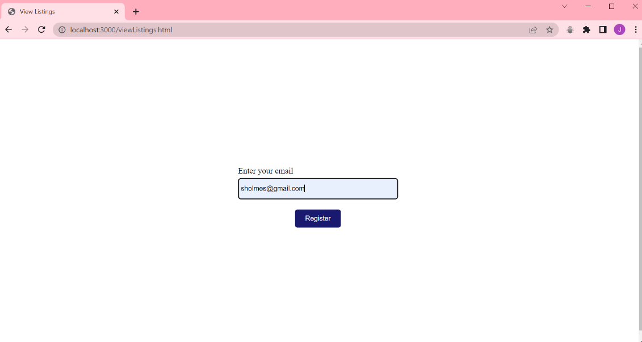

Here I have used the email of the user that was just registered.

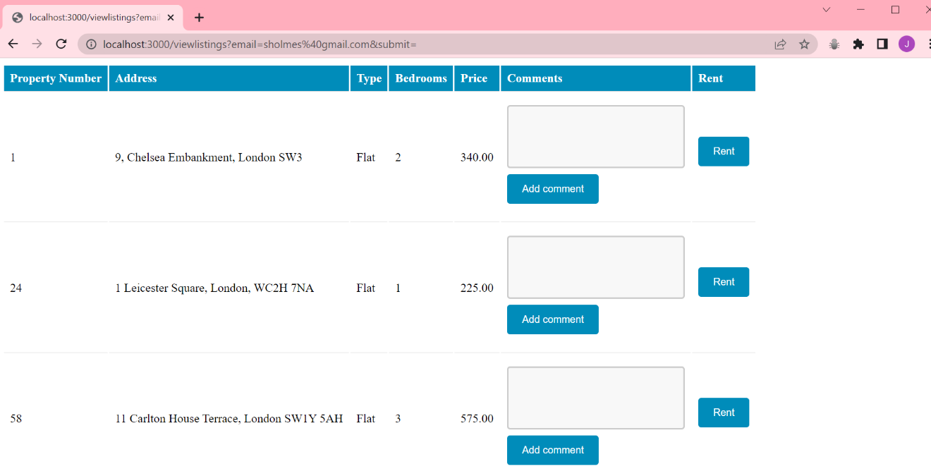

These are the properties that are available for rent.

It is important that a client gets the listings based on their preferences and to ensure this the following piece of code was written. It is also ensured that no property that is already leased appears on this list.

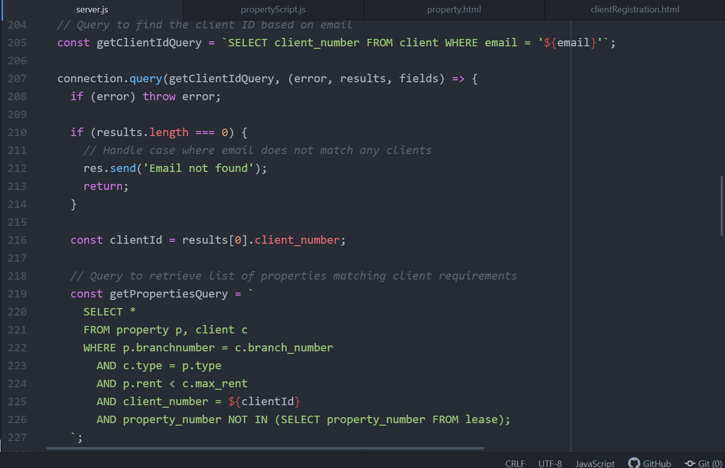

Now if the client does not like any of the properties in the listings, they can comment on it.

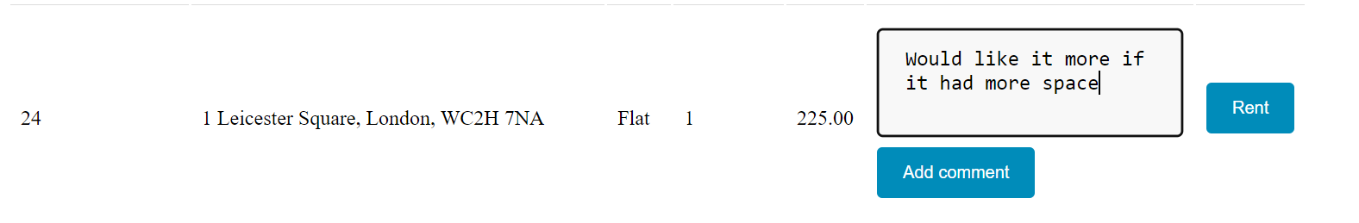

On clicking Add comment, the console will log “Comment added successfully.”

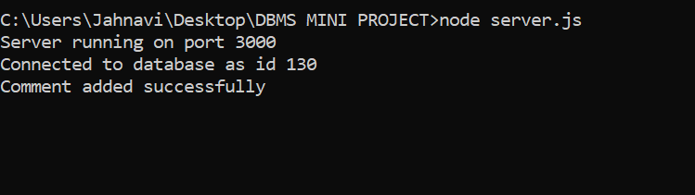

This comment will be added in the property_comments table.

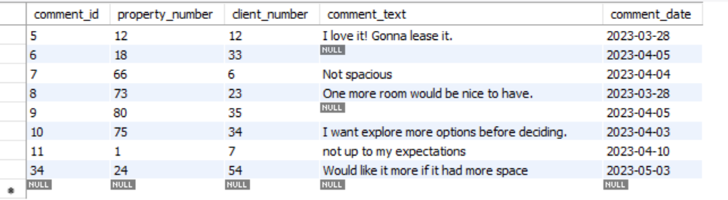

You can observe that the comment is added in the property_comments table. You can also see that the client_number and property_number are consistent and the comment_date is set to the current date.

The property owners can register their property by going to the rent your property option.

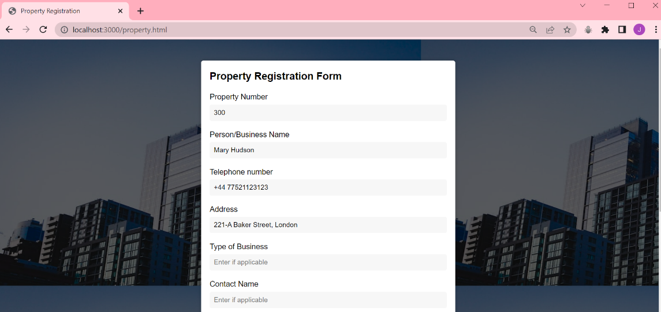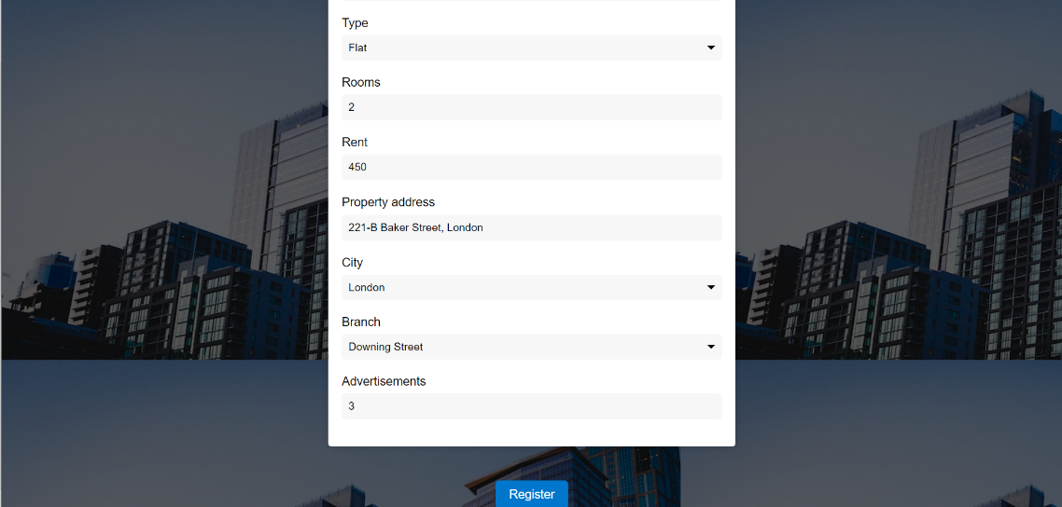

On clicking register,

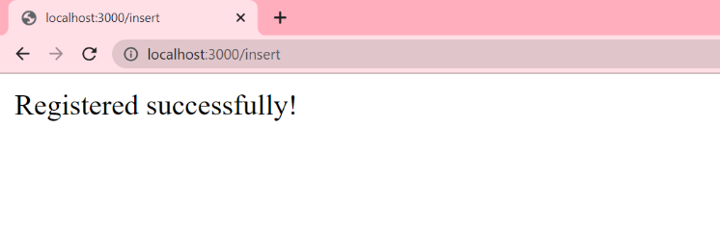

The data from this form will go to 2 tables i.e property and owner table.

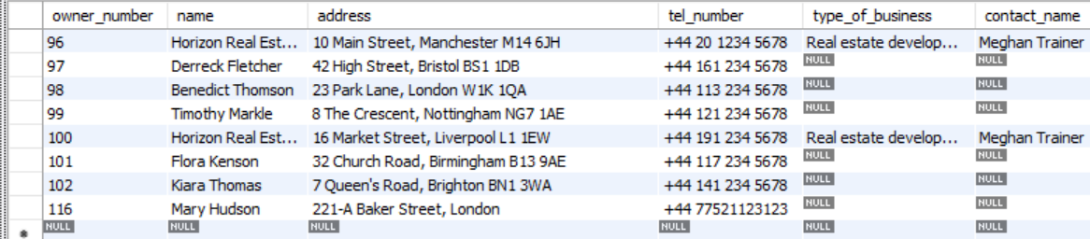

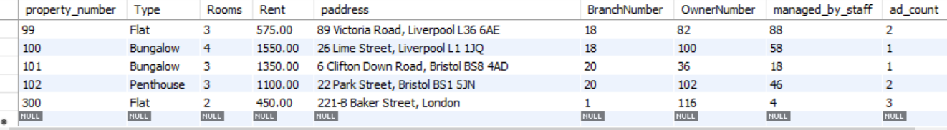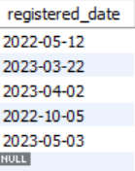

You can see that the data is consistent(owner_number and OwnerNumber are the same).

As this property fulfills all the requirements of “Sherlock” and is also registered at the same branch as him, so this property should appear on the listings page. Let us verify that.

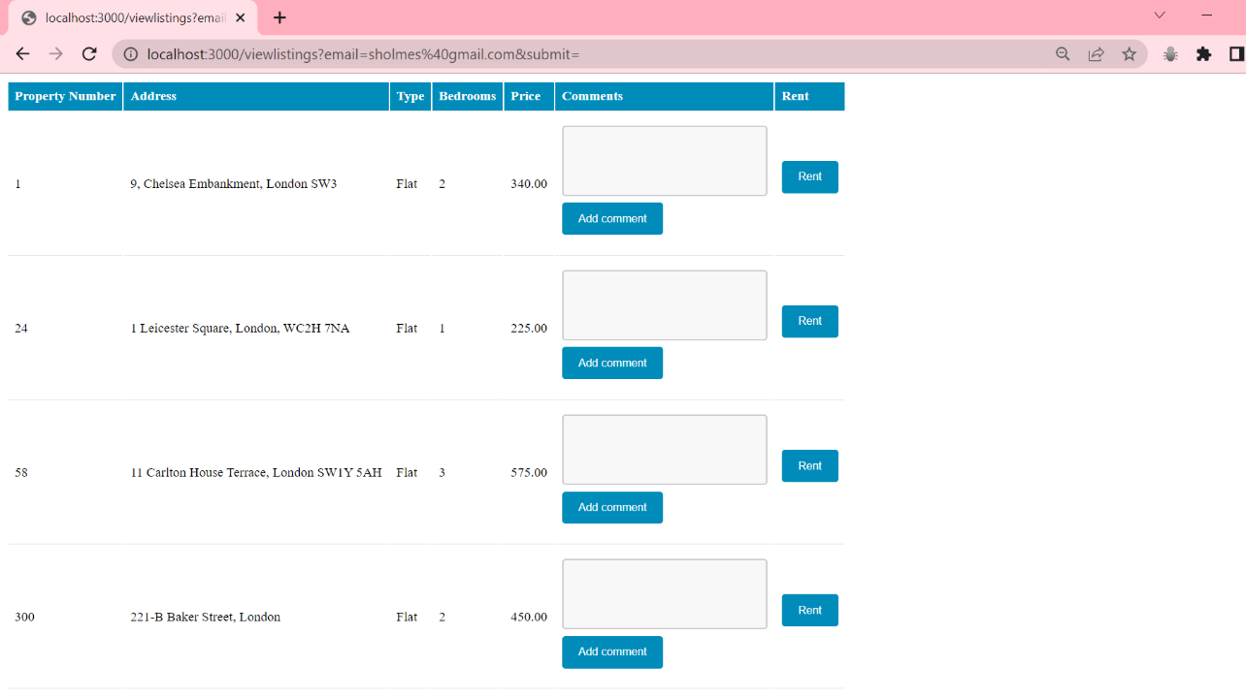 

And the verification is successful!

Now on clicking rent, you will be lead to the following page

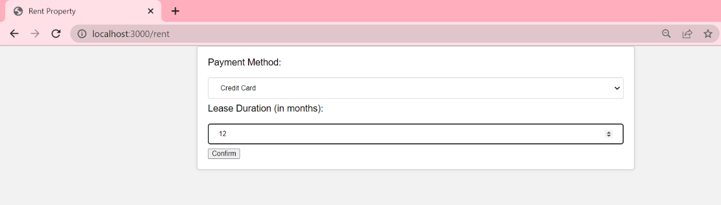

On confirming,

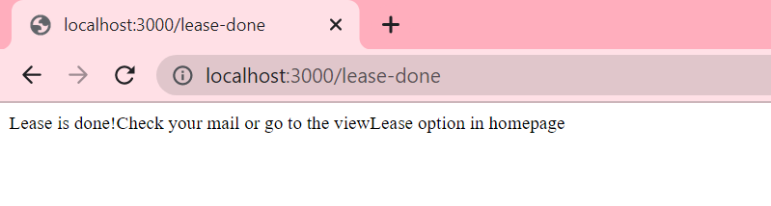

So to view the lease, we can go back to home page and click on the viewLease option

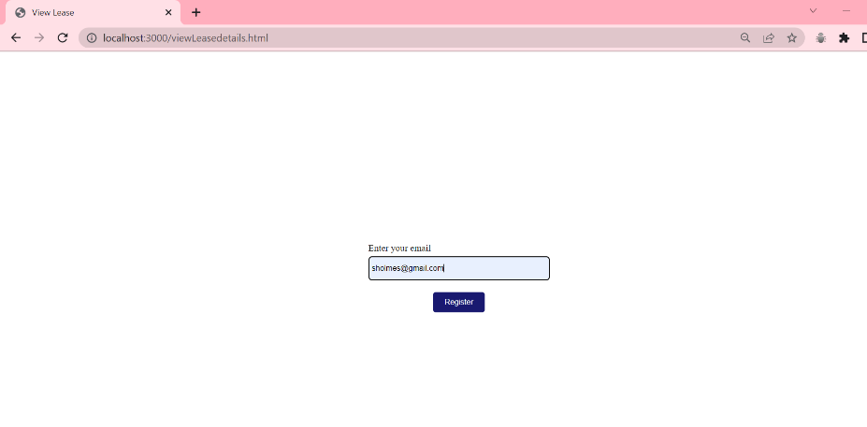

This will again ask for the email and upon submitting , you will be able to see your lease.

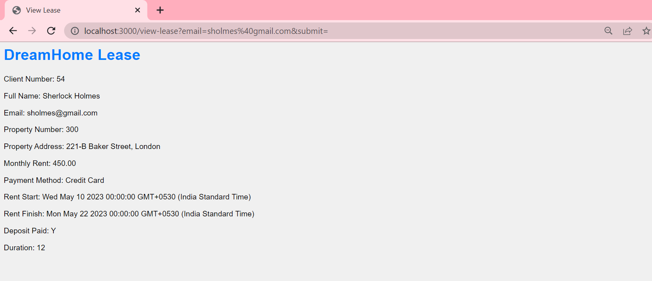

Also, the details of the lease will be stored in the lease table.

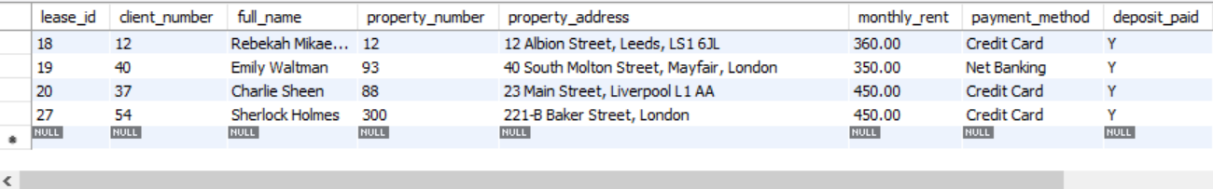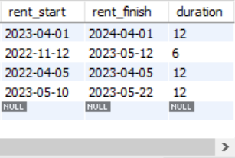

This concludes the functionalities from the user (owner and client) end.

Let us now see the functions that an admin can perform.

The admin can login using his credentials.

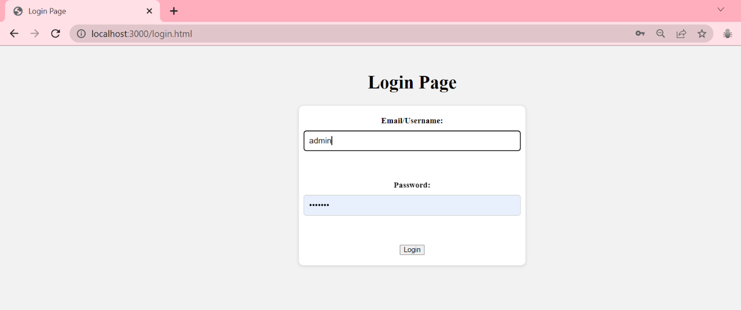

The admin page looks like this! 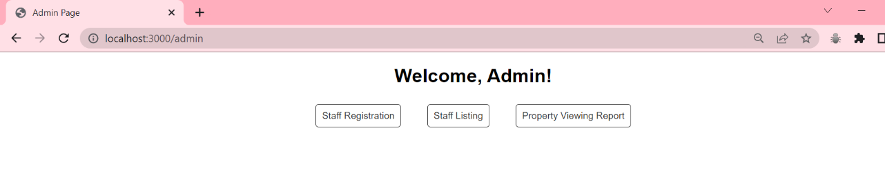

1.Staff Registration will allow the admin to register staff for any particular branch.

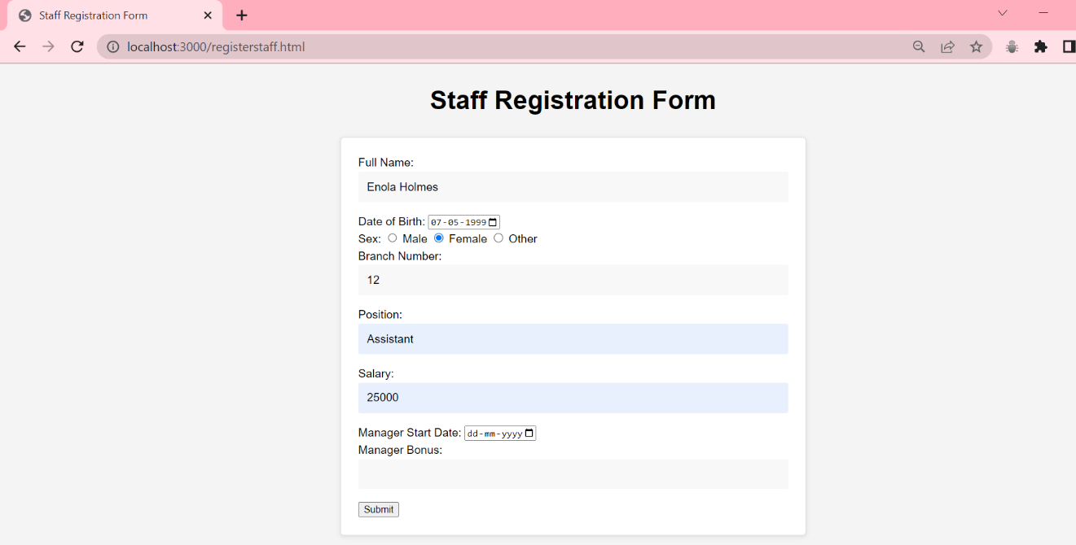

Upon clicking submit, the staff will be registered and the details will be visible in the staff table.

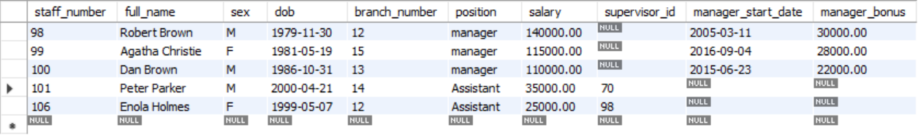2. The admin also can view the staff listings i.e the staff working in a particular branch.

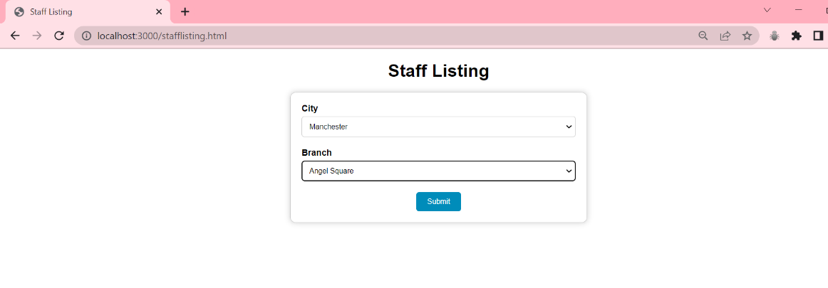

Here, the option to choose the branch is given. Now on submitting this, the admin will be able to view the staff at that branch.

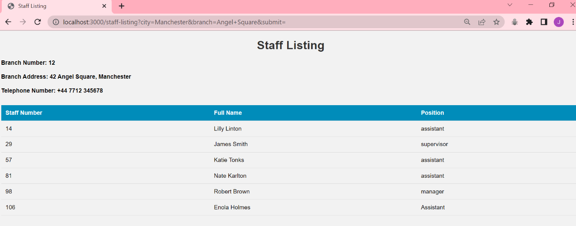

You can also see that the staff that we just registered is also shown here. This confirms the working and consistency of data.

3.The admin can access the property viewing report i.e he/she can see the comments on a particular property . This will be helpful to sell properties that are on the market for too long . By checking the comments, we will be able to know if something is wrong with the property.

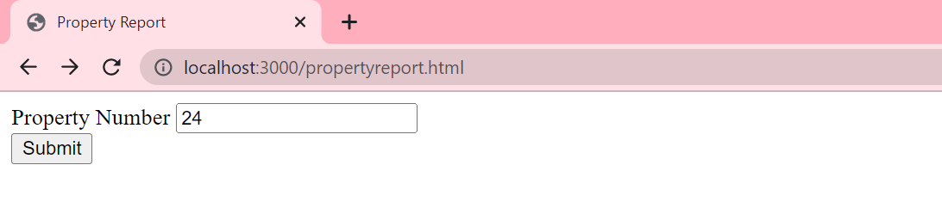

On submitting , the admin will be able to view the report on that property.

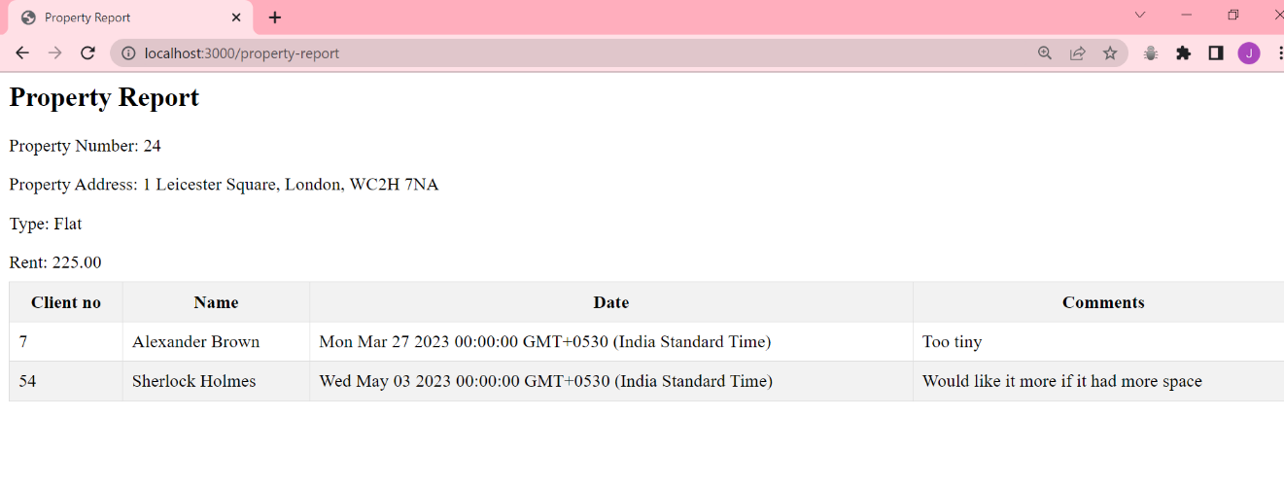

This concludes the description of the working software.

# Conclusion

In conclusion, Dream Home is an innovative solution for real estate businesses that seek to streamline their property management processes and provide exceptional customer service to their clients. With its user-friendly interface and basic features such as property listings, client management, and rental transactions, the system has the potential to revolutionize the rental industry by offering an efficient and convenient platform for both property owners and tenants. However, there is still room for improvement and expansion of the system's capabilities, such as the inclusion of payment processing and advanced search filters. Nonetheless, Dream Home is a promising tool for real estate businesses looking to differentiate themselves in the market and provide their clients with the home of their dreams.